NAME: RAMYA RAMESH

USN: 1BM19CS227

**PROGRAM 6: ORDER PROCESSING DATABASE**

TABLES:

CREATE DATABASE ORDPROCESS;

USE ORDPROCESS;

CREATE TABLE SALESMAN(SALESMAN_ID INT,

NAME VARCHAR (20),

CITY VARCHAR (20),

COMMISSION VARCHAR (20),

PRIMARY KEY (SALESMAN_ID));

DESC SALESMAN;

CREATE TABLE CUSTOMER

(CUSTOMER_ID INT,

CUST_NAME VARCHAR (20),

CITY VARCHAR (20),

GRADE INT,

SALESMAN_ID INT,

PRIMARY KEY (CUSTOMER_ID),

FOREIGN KEY(SALESMAN_ID) REFERENCES SALESMAN (SALESMAN_ID) ON DELETE SET NULL);

DESC CUSTOMER;

CREATE TABLE ORDERS

(ORD_NO INT,

PURCHASE_AMT REAL,

ORD_DATE DATE,

CUSTOMER_ID INT,

SALESMAN_ID INT,

PRIMARY KEY (ORD_NO),

FOREIGN KEY(CUSTOMER_ID) REFERENCES CUSTOMER(CUSTOMER_ID) ON DELETE CASCADE,

FOREIGN KEY(SALESMAN_ID) REFERENCES SALESMAN(SALESMAN_ID) ON DELETE CASCADE);

DESC ORDERS;

INSERT INTO SALESMAN VALUES (1000,'JOHN','BANGALORE','25 %');

INSERT INTO SALESMAN VALUES (2000,'RAVI','BANGALORE','20 %');

INSERT INTO SALESMAN VALUES (3000,'KUMAR','MYSORE','15 %');

INSERT INTO SALESMAN VALUES (4000,'SMITH','DELHI','30 %');

INSERT INTO SALESMAN VALUES (5000,'HARSHA','HYDERABAD','15 %');

COMMIT;

SELECT * FROM SALESMAN;

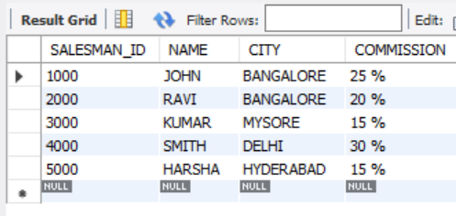

INSERT INTO CUSTOMER VALUES (10,'PREETHI','BANGALORE', 100, 1000);

INSERT INTO CUSTOMER VALUES (11,'VIVEK','MANGALORE', 300, 1000);

INSERT INTO CUSTOMER VALUES (12,'BHASKAR','CHENNAI', 400, 2000);

INSERT INTO CUSTOMER VALUES (13,'CHETHAN','BANGALORE', 200, 2000);

INSERT INTO CUSTOMER VALUES (14,'MAMATHA','BANGALORE', 400, 3000);

COMMIT;

SELECT * FROM CUSTOMER;

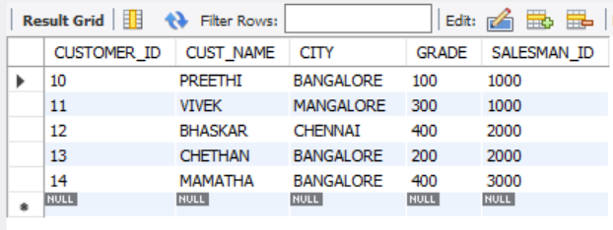

INSERT INTO ORDERS VALUES (50, 5000,'2017-05-04',10,1000);

INSERT INTO ORDERS VALUES (51, 450,'2017-01-20',10,2000);

INSERT INTO ORDERS VALUES (52, 1000,'2017-02-24',13,2000);

INSERT INTO ORDERS VALUES (53, 3500,'2017-04-13',14,3000);

INSERT INTO ORDERS VALUES (54, 550,'2017-03-09',12,2000);

COMMIT;

SELECT * FROM ORDERS;

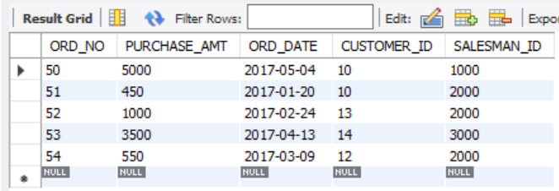

QUERIES:

1. **Count the customers with grades above Bangalore’s average.**

SELECT GRADE, COUNT(DISTINCT CUSTOMER_ID)

FROM CUSTOMER

GROUP BY GRADE

HAVING GRADE > (SELECT AVG(GRADE) FROM CUSTOMER WHERE CITY='BANGALORE');

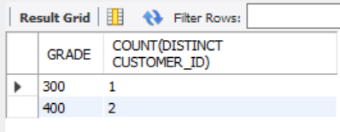

1. **Find the name and numbers of all salesmen who had more than one customer.**

SELECT SALESMAN_ID, NAME

FROM SALESMAN S1

WHERE 1 < (SELECT COUNT(*)

FROM CUSTOMER

WHERE SALESMAN_ID=S1.SALESMAN_ID);

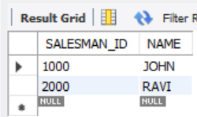

1. **List all salesmen and indicate those who have and don’t have customers in their cities**

SELECT S.SALESMAN_ID, NAME, CUST_NAME, COMMISSION

FROM SALESMAN S, CUSTOMER C

WHERE S.CITY = C.CITY

UNION

SELECT SALESMAN_ID, NAME, 'NO MATCH', COMMISSION

FROM SALESMAN

WHERE NOT CITY = ANY

(SELECT CITY

FROM CUSTOMER)

ORDER BY 2 DESC;

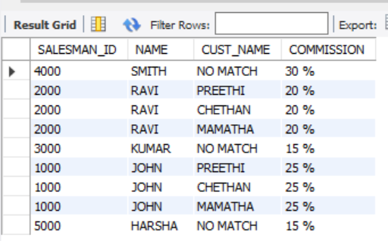

1. **Create a view that finds the salesman who has the customer with the highest order of a day.**

CREATE VIEW ELITESALESMAN AS

SELECT O.ORD_DATE, S.SALESMAN_ID, S.NAME

FROM SALESMAN S, ORDERS O

WHERE S.SALESMAN_ID = O.SALESMAN_ID

AND O.PURCHASE_AMT=(SELECT MAX(PURCHASE_AMT)

FROM ORDERS O1

WHERE O1.ORD_DATE = O.ORD_DATE);

SELECT * FROM ELITESALESMAN;

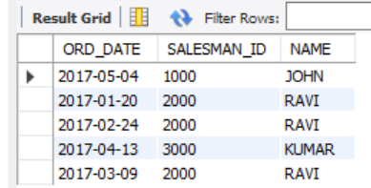

1. **Demonstrate the DELETE operation by removing salesman with id 1000. All his orders must  
   also be deleted.**

DELETE FROM SALESMAN

WHERE SALESMAN_ID=1000;

SELECT * FROM SALESMAN;

SELECT * FROM ORDERS;

SALESMAN Table:

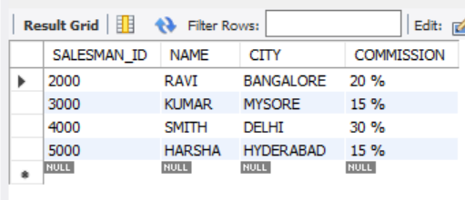

ORDERS Table:

